**Guidelines for Submitting Scientific Articles to KUIJIS**

**Khyber Saify1*; Second Authors Name2**

*1Department of Biology, Faculty of Education, Kunduz University, Afghanistan*

*2Department of English Language and Literature, Faculty of Education, Kunduz University, Afghanistan*

**\****1Corresponding Email:* [*info@kuijis.edu.af*](info@kuijis.edu.af)*, Phone Number : +93………….*

**Abstract**

‌ A scientific-research article must include sections such as: 1-Title, 2-Author details, 3-Abstract, 4-Keywords, 5-introduction, 6-research methodology (with subheadings such as the field of study, data collection methods, data analysis), 7-Results or research findings, 8-Discussion, 9-Conclusion & 10-Reference list.Abstract is complex of four parts including background, materials and methods, findings, and conclusion. The Abstract should be around 200 - 250 words. The abstract should not contain any undefined abbreviations. Important material, methods, findings and results should be pointed here. A brief conclusion with scientific contribution of the study must write here. The manuscripts can be submitted through [https://kuijis.edu.af/](https://kuijis.edu.af/index.php/kuijis/about/submissions). Further information regarding KUIJKS can be found at to the KUIJIS link. Original research papers and review papers can be accepted after peer-review process. The entire mauscript should not be more than 4 pages (A4). For an original research paper, the manuscript should be arranged in the following order:

**Keyword:** Afghanistan, Kunduz, KUIJIS, Template, Univesity.

**Introduction**

The introduction should be clear (including the necessary introduction of the subject, detailed background/research context, and purpose of the current work). All the main text of the manuscript should write in Times new roman at 10 font size. Headings should be bold, uppercase and 11 font size. Sub headings should be bold and italic with 10 font size. The introduction should briefly place the study in a broad context and highlight why it is important. It should define the purpose of the work and its significance (Kakar et al., 2019). The current state of the research field should be carefully reviewed and key publications cited (Rahmani, 2020). Please highlight controversial and diverging hypotheses when necessary (Kakar & Durani, 2018). Finally, briefly mention the main aim of the work and highlight the principal conclusions. As far as possible, please keep the introduction comprehensible to scientists outside your particular field of research.

This section should point out the research gaps, hypothesis, background, literature review, aim and objective of the study. Use 1.5 lines spacing throughout the manuscript in an A4 size. The margins should be 1 inch on all sides and the page number should be consecutively on the bottom of the page. Manuscript should have line number. For an original research paper, the manuscript should be arranged in the following order: Title page (title, full author (s) name, author affiliation and email of the corresponding author), abstract, keywords, introduction, materials and methods, results, discussion, conclusion, acknowledgements, conflict of interest and references. Tables and figures with legends should be inserted in the main text in order accordingly.

**Material and Method**

The method of the study should be prepared based on section one of the guidelines. For example:

***Study Area (sub heading)***

The Materials and Methods should be described with sufficient details to allow others to replicate and build on the published results. Please note that the publication of your manuscript implicates that you must make all materials, data, computer code, and protocols associated with the publication available to readers. Please disclose at the submission stage any restrictions on the availability of materials or information. New methods and protocols should be described in detail while well-established methods can be briefly described and appropriately cited.

***Samples Collection***

Interventional studies involving animals or humans, and other studies that require ethical approval, must list the authority that provided approval and the corresponding ethical approval code.

***Statistical Analysis***

Statistical software, methods of analysis and other relevant aspects should to be reported clearly. All statistical methods should to be pointed clearly.

**Results**

The results are based only on the findings of the present research. Research findings maybe included, possibly including figures and tables. It should provide a concise and precise description of the experimental results, their interpretation, as well as the experimental conclusions that can be drawn. All the relevant Tables in Figures should be cited accordingly.

**Sample APA Table**

**Table 1**. WHO Standard for Determining TDS in Water

| Quality | TDS Level (mg/L) |
| --- | --- |
| Excellent | 50-300 |
| Good | 300-600 |
| Fair | 600-900 |
| Poor | 900-1200 |
| Unfit | <1200 |

Top of Form

Bottom of Form

**Sample of Figure**

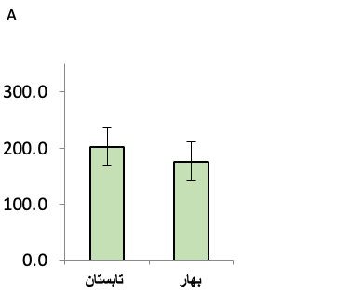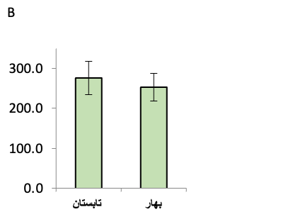

**\***

A B

A B

**Figure 1**. Average and standard deviation (SD) of Total Dissolved Solids (TDS) levels during the spring and summer seasons (A and B respectively).

**Note:** After a Table or Figure, the main text can be continued accordingly.

D**iscustion**

Discussion (comparing your study with others and important comparative aspects with references, possibly including recommendations from the researcher). Authors should discuss the results and how they can be interpreted from the perspective of previous studies and of the working hypotheses (Rani & Kumar, 2019). The findings and their implications should be discussed in the broadest context possible. Future research directions may also be highlighted (Wakiyama, 2016).

**Note:** If author/authors is/are willing to combine both result (Findings) and discussions for interpretations and analysis, it is permissible. Of course, with the condition that the findings are reported first and then discussed with all the principles and rules of writing scientific articles according to this guideline.

**Conclusion**

Conclusion (brief, from 100 to 200 words).This section is mandatory, with one or two paragraphs to end the main text. In this section, the biggest results obtained and can be presented from the results and discussion are briefly reported.

**Acknowledgment**

The authors also thank the anonymous reviewers for their helpful comments and suggestions.

***Data Availability Statement:***

The data that support the findings of this study are available from the corresponding author upon reasonable request.

***Conflicts of Interest***:

The authors declare that they have no known competing financial interests or personal relationships that could have appeared to influence the work reported in this paper.

**References**

**Here's how you would reference in APA style**

1. **Books**: Author's Last Name, First Initial. (Year of Publication). Title of Book (Edition if applicable). Publisher's Name.
2. **Journal Articles**: Author's Last Name, First Initial. (Year of Publication). Title of Article. Name of Journal, Volume Number(Issue Number), Page Numbers.
3. **Online Sources**: Author's Last Name, First Initial. (Year of Publication). Title of Article or Source. Website Name. URL.
4. **Theses or Dissertations**: Author's Last Name, First Initial. (Year of Publication). Title of Thesis or Dissertation (Doctoral dissertation or Master's thesis). University Name.
5. **Referencing a Section of a Book or Article**: Author's Last Name, First Initial. (Year of Publication). Title

**Examples**

* **Book**: Smith, J. D. (2010). The Power of Habit. Random House.
* **Online Source**: Brown, K. M. (2015). The Impact of Social Media on Mental Health. Psych Central. URL: [website address].
* **Thesis**: Miller, R. L. (2019). The Role of Leadership in Organizational Change (Doctoral dissertation). University of California, Los Angeles
* **Journal Article**: Johnson, A. B., & Williams, C. D. (2018). The Effects of Climate Change on Polar Bears. Environmental Science Journal, 15(3), 102-115.
* Kakar, K., Nitta, Y., Asagi, N., Komatsuzaki, M., Shiotsu, F., Kokubo, T., & Xuan, T. D. (2019). Morphological analysis on comparison of organic and chemical fertilizers on grain quality of rice at different planting densities. *Plant Production Science*, 22(4), 510-518.
* Rani, R., & Kumar, N. (2019). On the causal dynamics between economic growth, trade openness and gross capital formation: evidence from BRICS countries. *Global Business Review*, 20(3), 795-812.